**Brewing Terms**

This document has been created to help the beginner to brewing understand the terms and language of the craft/industry. Please note, this is not a technical guide, it is more of a “getting to know the basics” guide.

**DRAFT - getting closer to version one...**

**Table of Contents**

**Different types of Alcohol: 1**

Liquor or Spirits 1

Wine 1

Beer 2

**Sugars 2**

Dissolvable Sugars: 2

Mashable Malts: 2

Mashable Adjuncts: 2

Base Malts: 2

Cookable Adjuncts: 3

Non Fermentable Sugars: 3

**Wash: 3**

**Cuts: 3**

Foreshots: 3

Heads: 3

Hearts: 4

Tails: 4

Faints: 4

**How To Stop Your Still From "Puking" (boiling over): 4**

**Fusel oils / smells in moonshine: 4**

**Vinegar run: 4**

**Sacrificial run: 4**

**How to Clean copper: 5**

**Why you need copper in a still: 5**

Types of still 5

Reflux still: 5

Bubble Plate: 5

Perf Plate: 5

Stainless Steel Saddles: 5

Copper Saddles: 5

SPP (spiral prismatic packing): 5

Pot still: 5

Other types of still: 6

Air still: 6

**Condenser: 6**

**Distillation types: 6**

Heat Distillation: 6

Freezing Distillation: 6

**Yeasts 6**

Yeast Nutrient 7

How to make your own yeast Nutrients 7

**PH 8**

**Hydrometer 8**

Potential 8

Brix 8

Specific gravity (SG) 8

**Alcometer 8**

**Decant / Syphon / racking 9**

**Sediment 9**

**Bubbler / airlock 9**

**Common Bottle sizes and names 9**

**Conversions: 9**

Temperature 9

Liquid 9

Weight 9

Other 10

Brix / potential / specific gravity 10

**Brewing recipes 10**

Birdwatchers sugar wash recipe 10

**Notes 11**

**Acronyms 11**

**Untested 12**

Homemade Herbal Liqueurs 12

# Different types of Alcohol:

What is the difference between cider, beer, wine etc, most of it is to do with either the percentage of alcohol it is or the base sugars that it is brewed from. Below is a list with some examples.

Beer (1%-12% hops base)

Cider (1%-12% fruit base)

Mead (1%-12% honey base)

Wine(10%-20% fruit base)

wash (1%-20% any form of sugar)

rum (36%-50% sugarcane or molasses base)

Whiskey (36%-50% barley base)

## Liquor or Spirits

* ***Vodka*:** Made from the same fermentation process as beer or wine, with the added step of distilling to increase the strength of the drink, vodka is typically made from grains like wheat, sorghum, and corn, although Russian vodka is allegedly made from potatoes. Vodka has an ABV starting around 40 percent, but it can range as high as 95 percent.
* ***Gin*:** This type of liquor starts with a neutral distilled spirit, to which juniper berries and other aromatic botanicals are added. It is clear and has an ABV of 36-50 percent.
* ***Rum*:** Rum is fermented sugarcane, molasses, beet sugar, or other type of non-fruit sugar. It is then distilled to remove any sediment. It legally has 36-50 percent ABV.
* ***Whiskey***: Subdivided into scotch, bourbon, and Irish and Canadian whiskeys, these types of whiskey are aged in oak barrels that give them a unique caramel colour. ABV can range from 36 percent to 50 percent ABV, depending on how long it has aged.
* ***Tequila*:** Tequila is a Central and South American beverage made from fermented agave, which originally had some hallucinogenic properties in addition to being alcoholic. Tequila sold in the US is not allowed to have any additional drugs in it besides alcohol. The ABV is typically around 50-51 percent.
* ***Liqueurs*:** These beverages are distilled spirits combined with fruit, cream, sugar, or herbs to create a potent but flavorful beverage. Liqueurs include triple sec, amaretto, schnapps, and Sambuca. They may not have more than 15 percent ABV, on average.

## Wine

* ***Fortified wine*:** This is a type of fruit and/or honey alcohol that, either due to the addition of brandy or because it has been fermented long enough, has an ABV of 16-24 percent.
* ***Unfortified wine*:** This is a standard fruit or honey alcohol, such as mead or ice wine, with 16 percent or less ABV. The average ABV for wine is around 14 percent, although some, such as port, may be a little stronger. States may have individual mandates on how much sugar wine may contain as well.

## Beer

* ***Beer*:** This includes lagers, pilsners, flavoured beers, and ale. The ABV on beers ranges greatly, depending on the brewing process. Generally, the ABV is between 4 percent and 8 percent, with 5-6 percent being the standard for most beers in the United States. Some craft beers nowadays are as high as 12 percent.
* ***Malt beverage*:** While this category can include some types of beer, the ABV can range up to 15 percent, so it includes beers with additional alcohol added.  
  https://sunrisehouse.com/stop-drinking-alcohol/percentage-contents/

# Sugars

## Dissolvable Sugars:

Things that already contain fermentable sugar we just need to work out how to break these down into small enough pieces so the sugar will dissolve. Examples of things in this category are: Table sugar, brown sugar, syrups, molasses, all sorts of fruit, candy and soda.

## Mashable Malts:

Malted grains that have enough diastatic power to convert their own starch. All we need to do with these malts is mash them to break the starch down into fermentable sugar. Keep in mind that all Base Malts are Mashable Malts. But not all Mashable Malts are Base Malts. Some mashable malts only have enough diastatic power to mash themselves. Examples include: Malted Wheat, Munich malt, Belgian pale ale, British pale malt

## Mashable Adjuncts:

These are products that contain already gelatinized starch, but not enough enzymes to convert their starch. We can add these to a mash along with bottled enzymes or base malts. Often called steamrolled, steam flecked, hot rolled or torified. Examples include: Malted corn, steam flaked barley, rice bubbles, quick oats and bread.

## Base Malts:

These are malted grains that have an excess of enzymes that can be "donated" to convert other sources of gelatinized starch. You could mash a base malt all by itself or mash it with additional mashable adjuncts. Examples include: 6 row, high diastatic power distillers malt, ale malt, Vienna, most peated malts, Pilsner Malts American ale malt, malted wheat, marris otter etc (anything higher than around 100 Litner)

## Cookable Adjuncts:

These are starch sources that have not yet been gelatinized. We need to do the gelatinizing before we mash them. We can do this by cooking them. Generally, these starch sources are cooked by boiling them to make a porridge. But they can be cooked in other ways, for example roasting or steaming. Examples include rice, flour, potato, raw barley and corn.

## Non Fermentable Sugars:

Non fermentable sugars can be used to sweeten cider / wine without the risk of over carbonation.  
Some sugars are; Xylitol, Erythritol, Stevia, Splenda, Lactose, Maltodextrin

# Wash:

It is your sugars, water, yeast mix that is being brewed for distillation, (to turn into a spirit). This is also known as low wines and high wines.

**Low Wines** (4%-20% ABV (alcohol by volume)) when distilled the first time, and

**High Wines** (20%-65% ABV) when the spirit has been distilled additional times.

**Backset -** Once a wash has gone through the distillation process, the remaining liquid in the boiler is called backset. *(Apart from rum, where it's called “dunder”).*

# Cuts:

The process of spirit collection from the still run. Collecting it in up to 200ml lots/jars to be able to sample the separate flavours coming off to add them to the finished product or to put them to the side.

(https://www.diffordsguide.com/encyclopedia/198/bws/distillation-the-science-of-distillation)

## Foreshots:

The first 50-100ml or so of the spirit that comes out of the still at the start of the run, this contains toxic components so should not be drunk. (can use it like methylated spirits or for cleaning). There is no set calculation for how much to remove, it's mostly done by smell and taste, but most of the time if you are doing cuts you will exclude a lot more as it will be in the heads section.

## Heads:

The start of the spirit run (after the foreshots) normally good but can have differing flavours. Usually you do not add this into your "good spirit mix" or if you do, you might just add a small amount…

## Hearts:

The middle of the spirit run, said to be the cleanest, nicest tasting part. This is the best drinkable stuff that you keep.

## Tails:

The end of the spirit run, can give strong or off or yeasty flavours. Usually you do not add this into your "good spirit mix" or if you do you might do a small amount…

## Faints:

The mix of the heads and tails that did not make the cut to be added into the final product.

# How To Stop Your Still From "Puking" (boiling over):

Puking is when you run your still and the content foams/bubbles up and comes out the column without refluxing (so it pretty much transfers from the still out..)

Puking is more susceptible from a Grain mash (beer) or a Molasses wash, to minimise/stop this, either put less in (to leave more head room) or add oil to the top, (think of it like boiling spuds, pasta).

# Fusel oils / smells in moonshine:

To remove fusel oil from moonshine Add **8-10 grams of baking soda per 1 litre of moonshine**, stir, and infuse for 20-30 minutes. Then stir again and leave for 10-12 hours. After this, drain the top liquid layer and remove the sediment at the bottom. Soda is good for getting rid of fusel oils that cause an unpleasant flavour or smell.

<https://moonshiners.club/clearing-moonshine-getting-rid-bad-smell/>

# **Vinegar run:**

this is a cleaning run to clean the still after it has been sitting for a while, to do this you 50/50 vinegar and water (5L of each is recommended) and run the still without using cooling through the condenser for the first 5 mins, this will put hot vinegar steam throughout the sill and clean it out, you might notice a blue colour in the collection pot, this is from the copper, make sure it's clear before you finish.

# **Sacrificial run:**

Some people talk of a sacrificial run, to run an amount of 40% spirit through a newly built still or to aid in the cleaning after a vinegar run, you can just do a vinegar run, there is no evidence that running spirit through after a vinegar run will do anything. But the choice is yours.

# How to Clean copper:

Alkaline for breaking down organic matter

Acidic for breaking down mineral build up

**Make an acid wash**

100g of citric acid to 20L of water (100/20 = 5 grams) (approximately 1 teaspoon per litre of water)

Then soak the copper parts to remove the impurities, you will notice a colour change.

**Neutralise the acid**

Once you have done the acid wash, rinse it in water, then make a base solution to neutralise the acidity. To do this use baking soda, you dilute your base (the baking soda) the same way that you diluted the citric acid. (approximately 1 teaspoon per litre of water).

# Why you need copper in a still:

You should have copper in your still as it will remove sulphur compounds, this can be as a copper column or you could have copper saddles in the top of your still. They need cleaning after a period of time to continue to work.

# Types of still

## Reflux still:

### Bubble Plate:

<https://www.youtube.com/watch?v=WZeVAE-RXqI>

### Perf Plate:

<https://www.youtube.com/watch?v=WZeVAE-RXqI>

### Stainless Steel Saddles:

### Copper Saddles:

### SPP (spiral prismatic packing):

## Pot still:

## Other types of still:

### Air still:

# **Condenser**:

A method of cooling the steam, usually a copper coil with water passed through or surrounding water passed by, this cools the steam vapours and helps them to form a liquid.

**Reflux condenser:** the condenser in the top of the column that cools the vapour, allowing/supporting the saddles or plates to reflux.

**Product condenser:** the longer type condenser at the last stage of the still, condensing the product vapour into a liquid.

Shotgun condenser, it has multiple internal tubes for product to cool in, and fluid that goes round the outside, it is usually shorter that a product condenser

# Distillation types:

There are two main types of distillation, both methods remove water to concentrate the wash.

## Heat Distillation:

The main method is by heating the wash and then condensing the vapour to collect a liquid leaving the water behind. This is the most common method, and has many variants of this process depending on what product you want to finish with. (look at still types for more details)

## Freezing Distillation:

The other is by freezing and allowing the water to drip off while thawing, then freezing and thawing again multiple times. The freezing method has a drawback, in that you can not separate the foreshots, heads, hearts or tails, this method is not recommended for long time use as it leaves all the toxins in and does not give you the option of doing cuts.

# Yeasts

Not all yeasts are the same, they all have a Temp Range,Tolerance to alcohol Percentage % and their own flavour, Below is a list of common yeasts with their respective details to help you choose which ones to use.

| **Yeast Name** | **Alcohol tolerance** | **Temperature Range In C** | **Yeast Flavour** | **Note** |
| --- | --- | --- | --- | --- |
| Bakers Yeast | 14% | 10 - 32 |  | Tested - Edmons all purpose Active Yeast, for sugar wash, works well |
| Lalvin EC 1118 | 18% | 10 - 30 | Neutral | Great allrounder |
| Lalvin Rhone 2226 | 18% | 15 - 28 | Enhanced Varietal Character |  |
| Lalvin DV10 | 18% | 10 - 35 | Neutral |  |

<https://www.lallemandwine.com/wp-content/uploads/2017/12/Quick-Yeast-References-Chart_2018_LR.pdf>

## Yeast Nutrient

Yeast nutrient is something that can help the yeast to survive during its process. When yeast reproduces they require things like amino acids, nitrogen, fatty acids and vitamins to form new cells. this helps it not get stressed and cause off flavours, this can also help in the speed that it processes the sugars into alcohol, (this can come in many forms, for example, you can buy packets of yeast nutrient from the shops which will have things like nitrogen in them or you can add things yourself, like tomato paste).

## How to make your own yeast Nutrients

<https://stillontap.ca/how-to-make-your-own-yeast-nutrients/>

<https://homebrewanswers.com/yeast-nutrient-use/>

A Yeast Nutrient mix is the best to use as it removes variables – you know what the dosage is every time, you know what will happen, and there is no flavour impact.

Should you want to make your own batch of yeast nutrients; the following recipe will provide you with a relatively potent mixture:

40g of Di-Ammonium Phosphate

747g of Ammonium Sulphate

2g of Thiamine

1g of Potassium Tartrate

10g of Bentonite

The result will be a mixture of approximately 800g of Nutrients, of which you only need to add 3 to 5 grams per 20 lt fermentation.

Be careful of adding too much nutrient, especially Nitrogen, as residual Nitrogen can turn into Ammonia during distillation, stripping Copper from the inside of the Still, which can cause Blue Distillate. This might look cool, but is dangerous.

# PH

Is the reading of the acidity or alkalinity of a solution, it goes between 0 and 14 where 7 is neutral (water), lower values are more acidic and higher values more alkaline. Yeast likes to be more acidic and prefers a range between 4.6-6. Citric acid will reduce the number and baking soda will increase the number.

# Hydrometer

A hydrometer is an instrument for measuring the density of liquids. It operates based on the Archimedes principle that a solid body displaces its own weight within a liquid in which it floats. In our case we are measuring sugars. With this we can measure the starting sugars and then the finished sugars to work out the alcohol content of the finished product. We can also tell if the brew is still going (or if it needs help starting again) or if it has fully finished (no more sugars). Please note, most hydrometers are calibrated at 20°c so your fluid needs to be at that temperature or it will not be an accurate reading (you can convert your reading for temperature difference)

## Potential

Some hydrometers have a potential scale, this is given as a percentage and reads the sugar content and gives the potential that the alcohol can be if it uses all the sugars up. To work out the alcohol content you take the initial reading and then minus the finished reading. I.e. if you started at 12% and it brewed down to 1% your finished product is 11%.

## Brix

Some hydrometers have a brix scale, one degree Brix is 1 gram of sucrose in 100 grams of solution and represents the strength of the solution as percentage by mass. Some brewers use this and then convert it into a potential to find the alcohol content.

## Specific gravity (SG)

In the standard hydrometer scale, known as the specific gravity scale, distilled water equals 1.000, the initial point of measurement. Liquids lighter than water are scaled below 1.000 specific gravity, and liquids heavier than water are scaled above 1.000 specific gravity.

# Alcometer

This is a device that has a scale on it and is floated in the spirit for measuring alcohol content of spirits, this can not be used for non distilled products such as beers, ciders and wines. (look up hydrometer for the process of reading the content for beers, ciders and wines)

# Decant / Syphon / racking

Decanting / Racking is moving the liquid from one bottle to another leaving the sediment or particles to help give a cleaner product, this is usually done using a syphon. (putting the product in the fridge first can help settle the particles to the bottom)

# Sediment

The yeast, both dead and alive and other matter that falls to the bottom of the bottle during fermentation.

# Bubbler / airlock

The airlock/bubbler is that funny little bit of plastic that affixes to the top of your brew bucket and bubbles away during fermentation. It creates an air gap so new air can not get in but gases can escape.

# Common Bottle sizes and names

Common names are Carboys and demijohns, these come in various volumes ranging from **4 to 25 L**

# Conversions:

<http://mbhp.forgottensea.org/sugars.html>

## Temperature

Celsius to Fahrenheit **°C** x 9/5 + 32 = **°F** i.e. (20c * 9) / 5 + 32 = 68F

Fahrenheit to Celsius (**°F** − 32) × 5/9 = **°C** i.e. (68f - 32) * 5 / 9 = 20c

## Liquid

<https://www.learntobrew.com/beer-calculations/>

**Gallons to Litres** for an approximate result, **multiply** the volume value by 3.785 i.e. 1 gallon = 3.785 Litres

**Quarts to Litres** for an approximate result, **divide** the volume value by 1.057 i.e. 1 quart = 0.946 Litres

## Weight

**Pound to kilogram** for an approximate result, **divide** the mass value by 2.205 i.e. 1 pound = 0.453 kgs

**Ounce to kilogram**  for an approximate result, **divide** the mass value by 35.274 i.e. 1 ounce = 0.028 kgs

## Other

**Tomato paste,** 1 millilitre equals 0.951 grams

<https://www.howmany.wiki/vw/--1--ml--of--tomato-paste--in--gram>

**bakers yeast**, bakers yeast comes in 3 forms, instant, active and fresh, because of this i will not put a formula in, instead you can visit the website.

<https://www.traditionaloven.com/conversions_of_measures/yeast_converter.html>

## Brix / potential / specific gravity

<https://www.vinolab.hr/calculator/gravity-density-sugar-conversions-en19>  
<http://mbhp.forgottensea.org/sgpat.html>

Converting between these values has a long formula, so it's easier to look at a chart or go to a calculation website. 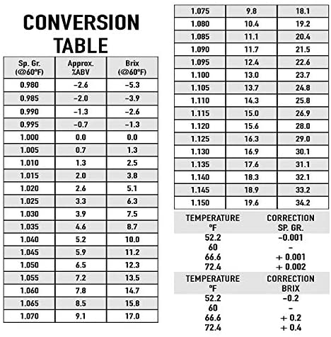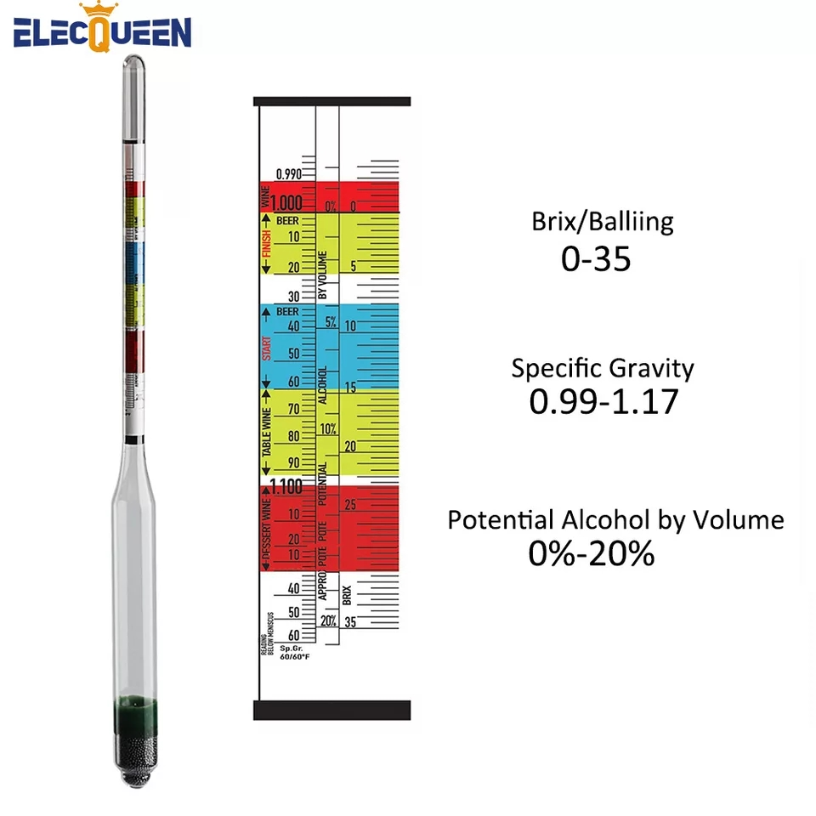

## 

# 

# Brewing recipes

## Birdwatchers sugar wash recipe

**For a 20 litre wash:**

187.5 ml (178 grams) tomato paste

Juice of 1 lemon

Approx. 4.5 KG sugar (1.09 Specific Gravity (SG) or (12% potential))

56.25g Bakers yeast (18 teaspoons)(4.5 TBSP)

20L water. (Only fill 10-15L cold then use the hot jug to get temps more accurate)

**Procedure:**

(Keep careful notes from start to finish for future reference.)

Mix paste, juice and about 3.5kg sugar with 15 litres of water at 30 C. Measure SG. (you are aiming for 1.09)

Carefully add water and sugar to bring mixture to a total of 20 litres, WITH A SG 1.09. (12% potential)

Temperature of the finished mixture should be 30C-35C.

Sprinkle 56.25g grams of yeast over the surface, stirring in. Place cover and airlock on.

Try to maintain water/wash in the 30-35C range.

Check temperature and stir/shake daily for the first 3 days.

Check SG, temperature and shake carboys gently daily.

After a total of 7-8 days SG should be .995. If not, wait until completion.

https://homedistiller.org/forum/viewtopic.php?f=14&t=5018

# Notes

Sugar wash will have less yeasty flavour if under 15%

Still column height for reflux still (15 - 20 times the width)

# Acronyms

ABV - Alcohol By Volume

SG - Specific Gravity

RC - Reflux Condenser

SPP - Spiral Prismatic Packing

VM - Vapour Management

LM - Liquid Management

# Untested

## Homemade Herbal Liqueurs

<https://m.northcoastjournal.com/humboldt/chartreuse/Content?oid=2133082>

An assortment of dried or fresh herbs, such as: lemon verbena, lemon balm, spearmint, fennel, thyme, angelica stems, sage, scented geranium, lemongrass, chamomile, bay, etc.

Whole (not ground) spices such as star anise, cloves, nutmeg, mace, cinnamon, saffron.

Citrus peel (the thin outer zest only) of lemons or oranges.

Simple syrup (equal parts sugar and water, heated until the sugar dissolves then cooled).

Most recipes call for combining all ingredients, in whatever quantity suits you, and letting them age together for anywhere from a few days to a few weeks.

But I have learned that fresh herbs can go from fabulous to dreadful very quickly in an infusion. So my suggestion is this: Carefully wash and trim your herbs, then add them to a clean mason jar. Fill it with the booze, cap it tightly, and let it sit in a dark spot for five to six hours. Taste it. If it's wonderful, you're done. If you're not satisfied, give it a little more time, but more than 24 hours is pushing it. Strain the herbs, then add citrus peel and spices, both of which can sit in alcohol for much longer without developing an off flavour.

Continue to taste it regularly. You might be pleased with the result after just a few days or a week. Then strain the mixture again, and add simple syrup to taste. Let it sit for three to four weeks, then drink it within a few months -- it's not intended to keep forever.